**Exponential growth model**

**What is it?**

The exponential growth model describes the growth of a population, where the population size always multiplies by the same factor in equal time steps. This model assumes that the environment is constant and that the amount of resources for each individual is constant regardless of the population size. The exponential growth model also assumes that there are no interactions with other species (predation, parasites, competition etc.).

If births and deaths can occur in at any point in time and not during specific seasons, it’s a continuous-time model of exponential growth.

**What can we do with it?**

The exponential growth model can be used to calculate the growth of microorganisms e.g., Bacteria or algae.   
It also can be used in population ecology to calculate the growth of invasive species in an ideal environment or the spreading of a disease.

**Formula**

$\frac{dn}{dt}$ = *b n*(*t*) - *d n*(*t*) = *rn*(*t*)

**Equilibrium**

$\frac{dn}{dt}$ = 0 → 0 = *rn*(*t*)

0 = *rn*(*t*) → $\frac{0}{n(t)}$ = $\frac{r}{n(t)}$  
→ 0 = *r*

**Parameters**

|  |  |  |
| --- | --- | --- |
| Parameter | Description | Range |
| n | Number of individuals | [0, ∞] |
| t | Time | [0, ∞] |
| *b* | Births | [0, ∞] |
| *d* | Deaths | [0, ∞] |
| r  (*b - d*) | Growth  (births – deaths) | [-∞,∞] |

**Examples**

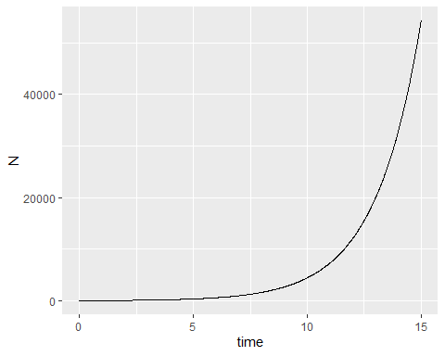

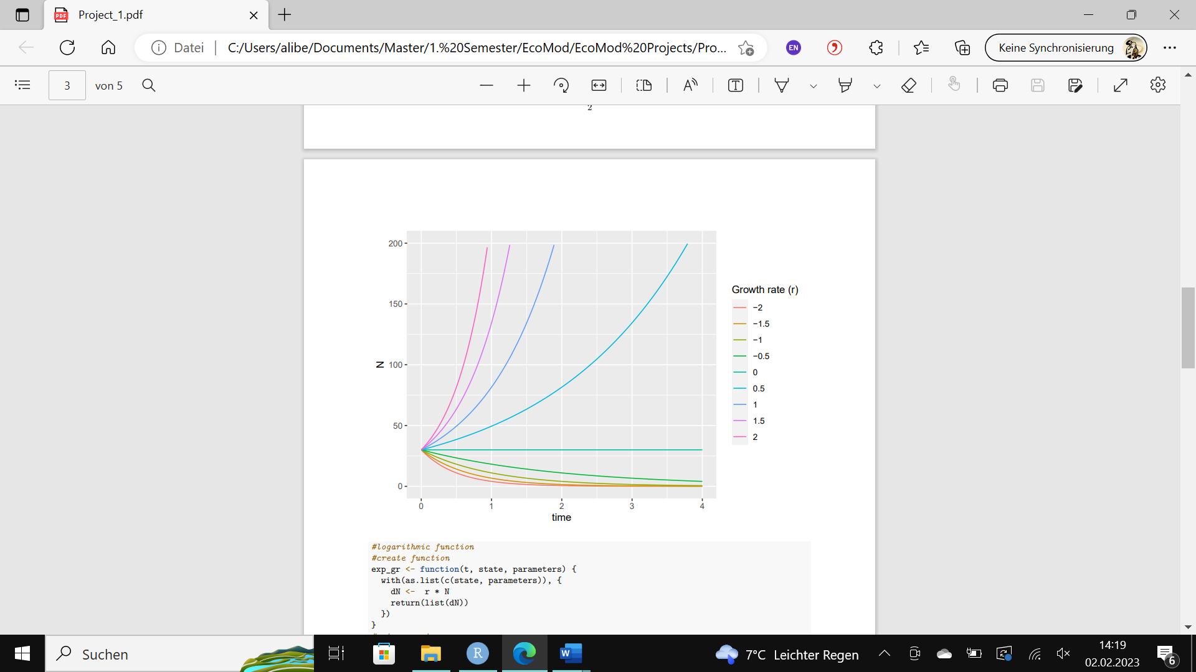

**R Code**

library(deSolve)

library(ggplot2)

## Continuous time model of exponential growth  
#create function  
exp_gr <- function(t, state, parameters) {  
 with(as.list(c(state, parameters)), {  
 dN <- r * N  
 return(list(dN))  
 })  
}

#set parameters   
parameters <- c(r = 0.5)  
state <- c(N = 30)  
times <- seq(0, 15, by = 0.01)

#plot  
exp_plot <- deSolve::ode(y = state, times = times, func = exp_gr, parms = parameters)  
exp_plot1 <- as.data.frame(exp_plot)  
ggplot2::ggplot(exp_plot1,aes(time,N)) + geom_line()

## Across a range of r values  
#set range  
r_range <- seq(-2, 2, by = 0.5)  
exp_plot2 <- array(NA,dim=c(length(times)*length(r_range),3),dimnames=list(NULL,c("time","N","r")))

#create loop for function across r values  
for(i in 1:length(r_range)){  
 parameters <- c(r = r_range[i])  
 out <- deSolve::ode(y = state, times = times, func = exp_gr, parms = parameters)  
 out2 <- as.data.frame(out)  
 exp_plot2[(((length(times) * i)+1) - length(times)):(length(times) * i),3] <- r_range[i]  
 exp_plot2[(((length(times) * i)+1) - length(times)):(length(times) * i),1:2] <- out[,]  
}  
exp_plot2 <- as.data.frame(exp_plot2)

#plot data  
p <- ggplot(exp_plot2, aes(time, N))  
p2 <- p + geom_line(aes(color = factor(r)))+labs(color="Growth rate (r)")  
p3 <- p2 + ylim(0, 200) + xlim(0,4)  
p3